Loqs – 3 homologs, involved in siRNA processing and biogenesis, also associates with the Dicer complex, known to be involved in nervous system development.

We are trying to study 3 homologs of Loqs and their role in siRNA processing through siRNA seq data in knockout mutants which have been rescued with each of the 3 homologs.

Transpsoson siRNAs, cis-nat-siRNAs among the (i.e naturally complementary RNAs to target).

Rescue Loqs B, D, show 25x-fold higher expression in hpRNA, which would include your microRNAs.

*Note how miRNA’s silence post transcription and does not cause direct degradation? While siRNA’s do

(MiRNA, siRNA, piRNA)

The human ortholog of LOQs is known as TRBP/PACT (which are themselves paralogs) and are non essential to dicer function.

Dicer complex can function normally, when it comes to miRNA’s woth perfect match, but requires LOQs to process miRNA’s with suboptimal matching (40% loqs dependence).

Dicer removes the “looped” region of the miRNAs.

3 known splice variants/ isoforms of LOQs (PA,PB,PD). PD binds to the siRNA dicer (dicer 2).

***Loqs* locus knockdown mutant’s mature siRNA level could be rescued with *loqs-PD* complementation.**

In summary, the overall miRNA abundance was only marginally (50%) increased by reintroduction of Loqs-PB in loqs mutant cells.

**The transposon matching endo-siRNAs are comparable with piRNAs in the sense that they induce homology-dependent repression, but their biogenesis is clearly different: a roughly equal distribution of sense-matching and antisense-matching endo-siRNAs implies a double-stranded precursor. This is substantiated by the dependence of endo-siRNAs on the enzyme Dicer-2 (Dcr-2).**

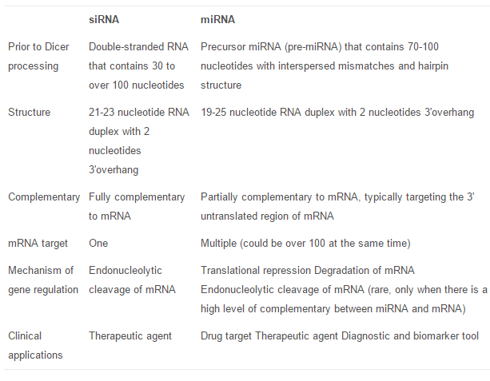

**060717 – first official meeting**

Initial mapping to DM3 drosophila, now we have to map it to **DM6**.

Ask Kenneth about **snakemake**? Make files? Chain dependencies? Describes chain dependencies and how to resolve them. See this in context of data pipelines. Unix Make, still good to use? Snakemake is a derivative of it. Learn **snakemake** readthedoc + tutorial. Modularizes the pipeline.

Modify and take the modified pipeline to use on other datasets, this is the key.

Understand the script first

Do it modularly. Buiding indeces is like one module, Mapping is another module, because the mappings are done sequentially.

Note Atlas accounts**. Slack**?

Code is on git. But we run all processes on atlas and do everything on atlas.

1. Understand it together, learn together -> Snake make modularization.
2. Then work on separate parts later, pre-processing, indexing.